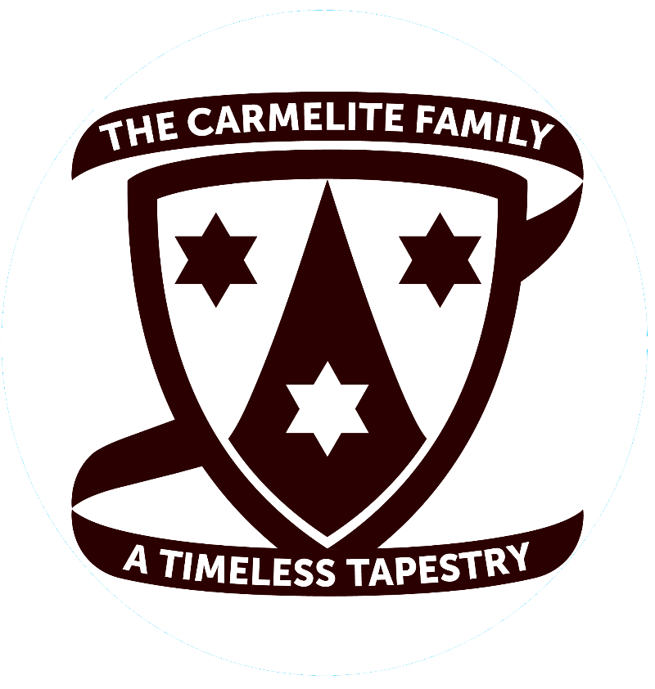

2025 Lay Carmelite Interprovincial Convocation
Provinces of St. Elias and The Most Pure Heart of Mary
June 27 - 29, 2025
The Catholic University of America
Washington DC
Co-Sponsored by the Center for Carmelite Studies

FOR REGISTRATION INFORMATION:
http://www.laycarmelitespcm.org/

